The World of Nutrients

Why is water important?
4 reasons why:
- Thermoregulation
- Transport of nutrients
- Solvent for chemical reactions
  - Without water, the metabolism is not effective
- Lubrication
Where does the net absorption of water occur in ruminants?
- The rumen and omasum (many plies/butchers' bilble)
  - Omasum had many folds for absorption
Where is the net absorption of water that occurs in all species?
- Illum jejunum, cecum and large intestine
Absorption: Illum jejunum
Digestion: Duodenum

List the most common water sources:
- Drinking water
- Water contained in or on feed
- Metabolic water
  - 1g of fat could release 1 g of water

Whenever the ________________ of an animal increases water intake _________________.
- (Temperature, size, activity), increases

At which stage of production is water consumption MOST essential?
- Lactation
  - Mother needs to have water to meet maintenance before producing milk
Label the growth curves
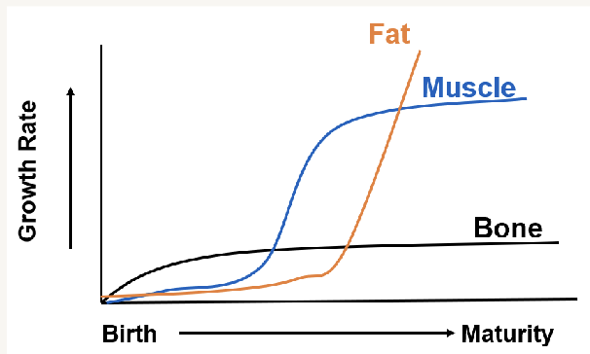
Label the energy table
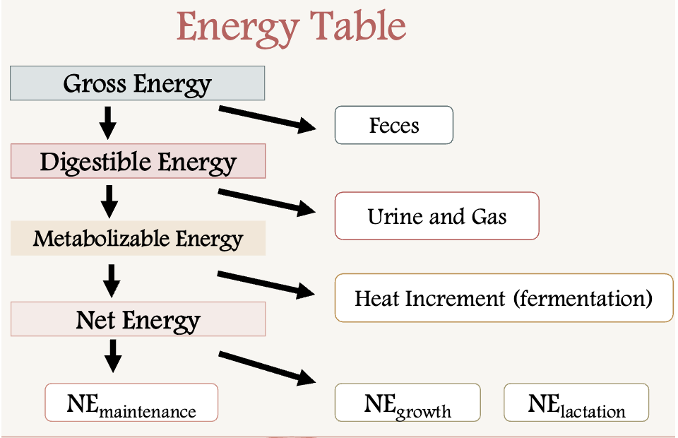

What are the clinical signs of dehydration? (cattle, sheep, horses, swine)
Cattle and sheep
- Sunken in eyes
- No lactation in dairy cattle
Horses
- In horses, their flanks will dissipate/ reduced skin elasticity
  - Skin hydration test
Swine
- Thirst
- Skin irritation
- Lack of appetite
- Salt poisoning is a big problem (often deadly), causing seizures, nervous system damage

Protein

What are proteins?
- Long chains of amino acids
  - Contain nitrogen -NH2 groups
What is the difference between an essential and non- essential amino acid?
Essential protein: must be provided in the diet (could not be produced in high enough quantities in the body)
Non-essential: could be synthesized in the diet

Why is protein supplemented in the diet?
Muscle (muscle function and growth)
Enzymes: catabolic reactions
Structural components
What is typically the most expensive nutrient?
Protein!
=
How many essential amino acids are needed in the diet of a growing animal?
10
Which amino acid is a semi-essential amino acid?
Arginine, because it needs to be supplemented in young animals diets but not in adult diets

How many essential amino acids are required In adult animals:
9

There are ________ naturally occurring amino acids
- 200

Microbes utilize ___________________ needed for amino acid synthesis in ruminants
non-protein nitrogen (NPN)

What is the first limiting amino acid?
Lysine
- The term limiting amino acid refers to an amino acid that is present in a food or diet in the lowest quantity relative to the body’s needs, therefore restricting the body’s ability to synthesize proteins
What are some limitations of crude protein?
- Crude protein looks at the overall nitrogen content within a feedstuff

List the essential amino acids ( Hint: PVT TIM HALL) :
Phenylalanine Threonine Hisodine
Valine Isoleucine Arginine
Tryptophan Methionine Lysine
Leucine

List the 4 protein structures and define them:
Primary structure: the linear sequence of amino acids
Secondary structure: arranged in a helix formation
Tertiary structure: A helix further folded onto itself
Quaternary protein: Two or more polypeptide chains united by non-covalent bonds

What are the limitations of crude protein?
- Assumes all nitrogen in feed is protein
- No information on the Amino Acids composition or digestibility

NPN: microbes use NPN to synthesis the amino acids, need carbs (energy) to help with the synthesis
Microbes do not touch by-pass proteins

- Over-supplementing NPN could result in ammonia toxicity. (leads to death)

Carbs

What are 3 types of carbohydrates?
- Sugars, starches and fibers

Carbs are formed through ______________ in plants
- Photosynthesis

Carbohydates have a gross energy of __________ kcal/g
- 4.1
- Carbs are the primary source of energy provided in a livestock diet
What type of bonds constitute starches, sugars, and fiber?
- Starches and sugars (alpha bonds)
- Fiber (Beta bonds)
Alpha bonds- easier to break down
Beta- broken down by microbes, cellulase breaks down cellulose
Polysaccharides: difficult to break down (microbes break them down better)

Fats have __________ times more energy than carbohydrates
2.25

The main product of fermentation are_______Volatile Fatty Acids__________

- The main energy source for ruminants, representing 70% or more of their energy supply.
- acetate, propionate, and butyrate

_____________ is the most abundant carbohydrate and primary plant structural component
Cellulose increases as plants mature
Lipids

What are the 3 main functions of lipids?
- Insulation
- Protection
- Energy
Lipids have______________ kcal/g of gross energy
- 9.4
Label the following fatty acids as saturated or unsaturated:
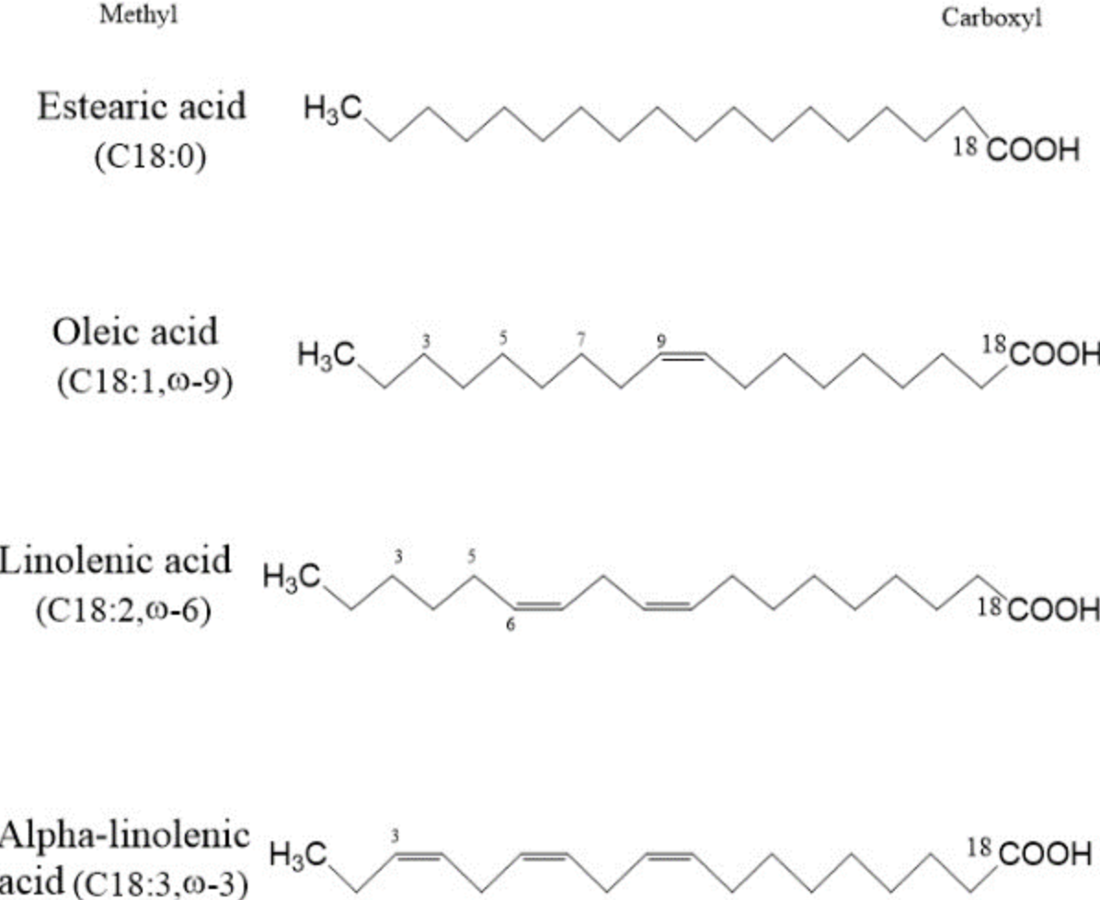
Saturated- non double bonds (hydrogens)
Unsaturated- double bonds

