Part 1: Protein & Amino Acid Metabolism
Define the following terms:
Deamination:
Transamination:

Urea Cycle:

Define glycogenolysis:

What is glycolysis?

What is the Citric acid cycle?

What is Gluconeogenesis?

Nicotinamide adenine dinucleotide (NADH) Is used for ____________________________________ in the Krebs cycle.

The 4 G’s:

Define the following terms:
- UIP

- DIP

- NPN

True/False:
- Ruminants have true amino acid requirements just like monogastrics.

b) Microbes in the rumen can convert NPN into microbial protein.

- The liver is the main site of the urea cycle.

Part 2: Metabolism of lipids
What molecule is considered the “molecular unit of currency”?

How much ATP per mole of glucose does the citric acid cycle produce?

What 4 pathways do dietary cholesterols go through after they are delivered to the kidneys?

How is lipoprotein expression affected during fasting?

Where is hepatic lipase (HL) secreted?

________________________________ starts a cascade of reactions which stimulate other enzymes which break down fat (Beta Oxidation)

What type of adipose tissue is obesity associated with?

What is leptin? What gene is associated with leptin production?

Which fat type is important for heat generation? What animals will this type of fat mainly be seen in?

Linolenic acid is a __________________________ fatty acid that is a precursor for _____________________________.

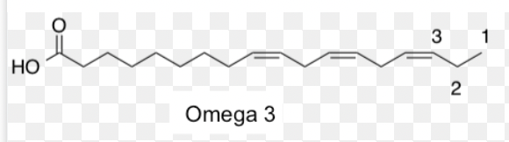

Things to keep in mind about the 2 fatty acids:

