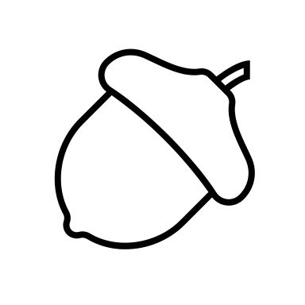 Vitamins and minerals + Feed Analysis

What are the 4 fat-soluble vitamins?

What are the two water-soluble vitamins?

What is the function of vitamins and minerals?

How can animals acquire minerals and vitamins?

Match the fat-soluble vitamin to its function:

List the water-soluble vitamins:

List the macro and micro (trace)minerals (hint: 7 macro, 8 micro) :
Macrominerals | Microminerals

Fed Analysis
Why is feed analysis important?

List the components of proximate analysis:

Label the following flow diagram
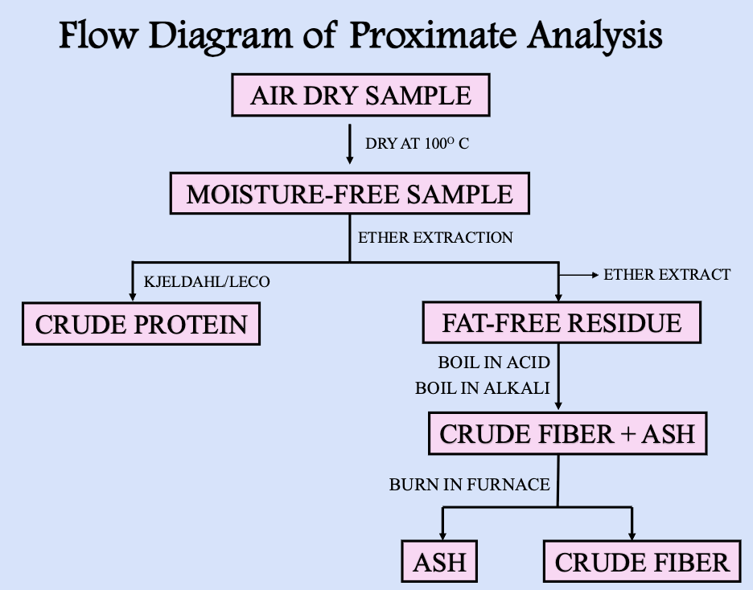
Formulas
Write the dry matter formula:

The percent moisture can be determined by:

Crude protein Formula:

Cost analysis formula:

Dry matter calculations
Wet sample: 36.8
Dry Sample: 27.4
What is the dry matter percentage?

Wet sample: 42.5
Dry Sample: 38.2
What is the dry matter percentage?

Dry matter intake
A lamb consumes 13 lbs of an alfalfa hay mix at 76% DM?
What is the DMI?

A livestock heifer consumes 22lbs of corn meal at 83% DM?
What is the DMI?

Cost analysis
Silage A: 84% moisture at $55/ton
Silage B: 52% moisture at $68/ton
Which is the better silage for dollar value?

Silage A: 74% moisture at $45/ton
Silage B: 66% moisture at $62/ton
Which is the better silage for dollar value?

Crude Protein

Ruminants need a source of ___________________for microbes to synthesize proteins
What are the two main methods of protein analysis?

What is the purpose of the Kjeldahl method?

List the limitations of proximate analysis:

Calculate the crude protein percentage:
Jack is raising swine and preparing them for the upcoming livestock show. He is trying to determine the crude protein content of the soybean meal he will be using to finish his swine. Knowing the Nitrogen content of his feed is 8.40%, what is the crude protein of his soybean meal?

What is NDF (Neutral Detergent Fiber)?

What is ADF (Acid Detergent Fiber)?

