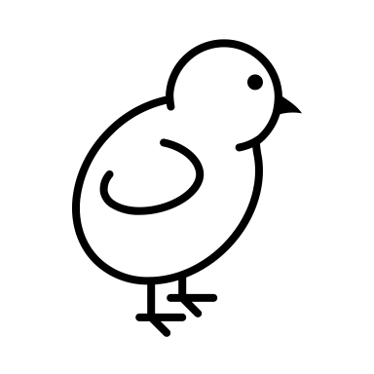Animal Feeding: Poultry Edition

Part 1: Matching Terms
Match the term to its correct definition. Write the correct letter next to the number.
Term | Definition
1. Broiler | A. Female chicken in her second year of laying eggs
2. Pullet | B. Final feed ration before meat processing
3. Hen | C. Chickens raised for meat
4. Grower | D. Feed for fast-growing chickens, usually high in energy
5. Finisher | E. Female baby chick or first-year layer
6. Starter | F. Feed blend for young birds in the early growth phase
7. Rooster | G. Adult male chicken

1 | C. Chickens raised for meat
2 | E. Female baby chick or first-year layer
3 | A. Female chicken in her second year of laying eggs
4 | D. Feed for fast-growing chickens, usually high in energy
5 | B. Final feed ration before meat processing
6 | F. Feed blend for young birds in the early growth phase
7 | G. Adult male chicken

What is a Straight Run?
- a random mixture of male and female baby chicks, usually less expensive than only pullets- may be fed longer
Bantams are:
- a miniaturized chicken of any breed; most breeds have a regular-size and a bantam variety
Why is Grit is important?
- It helps chickens digest food

Fill in the Blanks
- Chickens raised for both eggs and meat are called _______________________.
- __________________ is the outer coating of grain that is high in silicon.
- Chickens typically reach sexual maturity and begin laying eggs between __________ and __________ weeks of age.
- A feed blend high in calcium and protein, made for egg-laying chickens, is called __________________.
- The average slaughter age for broilers in the U.S. is __________ days at __________ lb.

- Layer-Broilers
- Bran
- 16 and 24 weeks
- Layer feed
- 47 days at 6.46 lb

Draw and label the grains of the kernel:
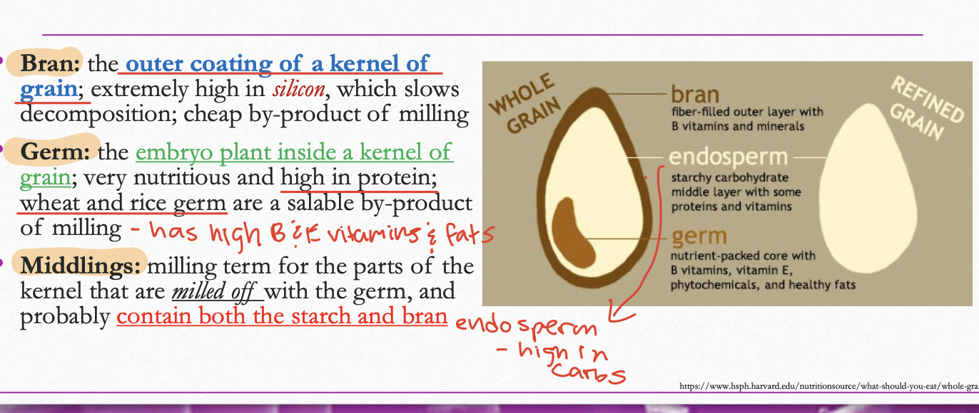

What feeding form (e.g., pellet, crumble, mash) would prevent selective eating and ensure balanced nutrition?
  - Pellets – because the birds eat the whole feed rather than picking out parts.

Describe two natural behaviors chickens use to find food:
  - Scratching in the dirt
  - Browsing for insects, grasses, or seeds
Why is clean water so important for chickens?
- Chickens need water for digestion and nutrient absorption; without it, feed intake drops, limiting growth and egg production.
- Water intake is the number 1 limiter of feed intake beyond body weight

What happens to white meat yield if lysine levels are too low in feed?
  - White meat yield may decrease if lysine levels are too low in the ration.
- Lysine is critical for muscle development

What is the relationship between nutrition and growth rate?
Better nutrition (especially early protein and energy levels) supports faster and larger growth in broilers. Higher feed quality improves skeletal and muscle development, allowing birds to reach larger weights at younger ages.

