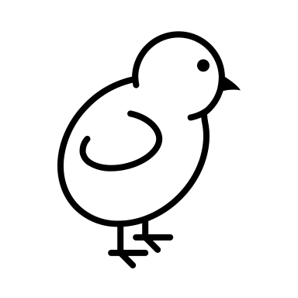Animal Feeding: Poultry Edition

Part 1: Matching Terms
Match the term to its correct definition. Write the correct letter next to the number.
Term | Definition
1. Broiler | A. Female chicken in her second year of laying eggs
2. Pullet | B. Final feed ration before meat processing
3. Hen | C. Chickens raised for meat
4. Grower | D. Feed for fast-growing chickens, usually high in energy
5. Finisher | E. Female baby chick or first-year layer
6. Starter | F. Feed blend for young birds in the early growth phase
7. Rooster | G. Adult male chicken

What is a Straight Run?

Bantams are:

Why is Grit is important?

Fill in the Blanks
- Chickens raised for both eggs and meat are called _______________________.
- __________________ is the outer coating of grain that is high in silicon.
- Chickens typically reach sexual maturity and begin laying eggs between __________ and __________ weeks of age.
- A feed blend high in calcium and protein, made for egg-laying chickens, is called __________________.
- The average slaughter age for broilers in the U.S. is __________ days at __________ lb.

What feeding form (e.g., pellet, crumble, mash) would prevent selective eating and ensure balanced nutrition?

Describe two natural behaviors chickens use to find food:

Why is clean water so important for chickens?

What happens to white meat yield if lysine levels are too low in feed?

What is the relationship between nutrition and growth rate?

