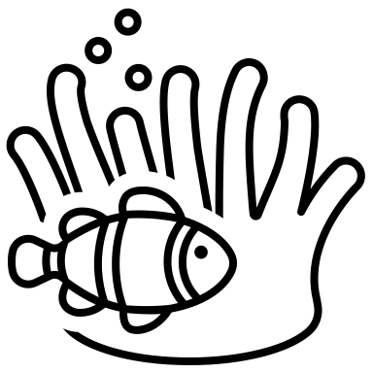The World of Nutrients

Why is water important?

Where does the net absorption of water occur in ruminants?

Where is the net absorption of water that occurs in all species?

List the most common water sources:

Whenever the ____________________of an animal increases water intake_____________________.

At which stage of production is water consumption MOST essential?

Label the growth curves
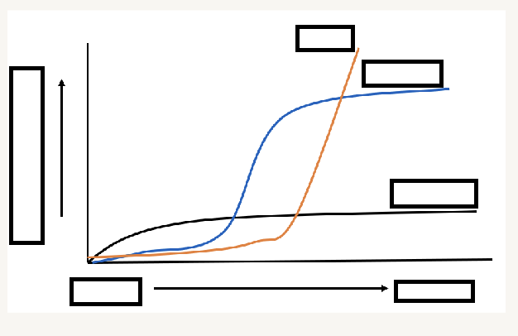
Label the energy table
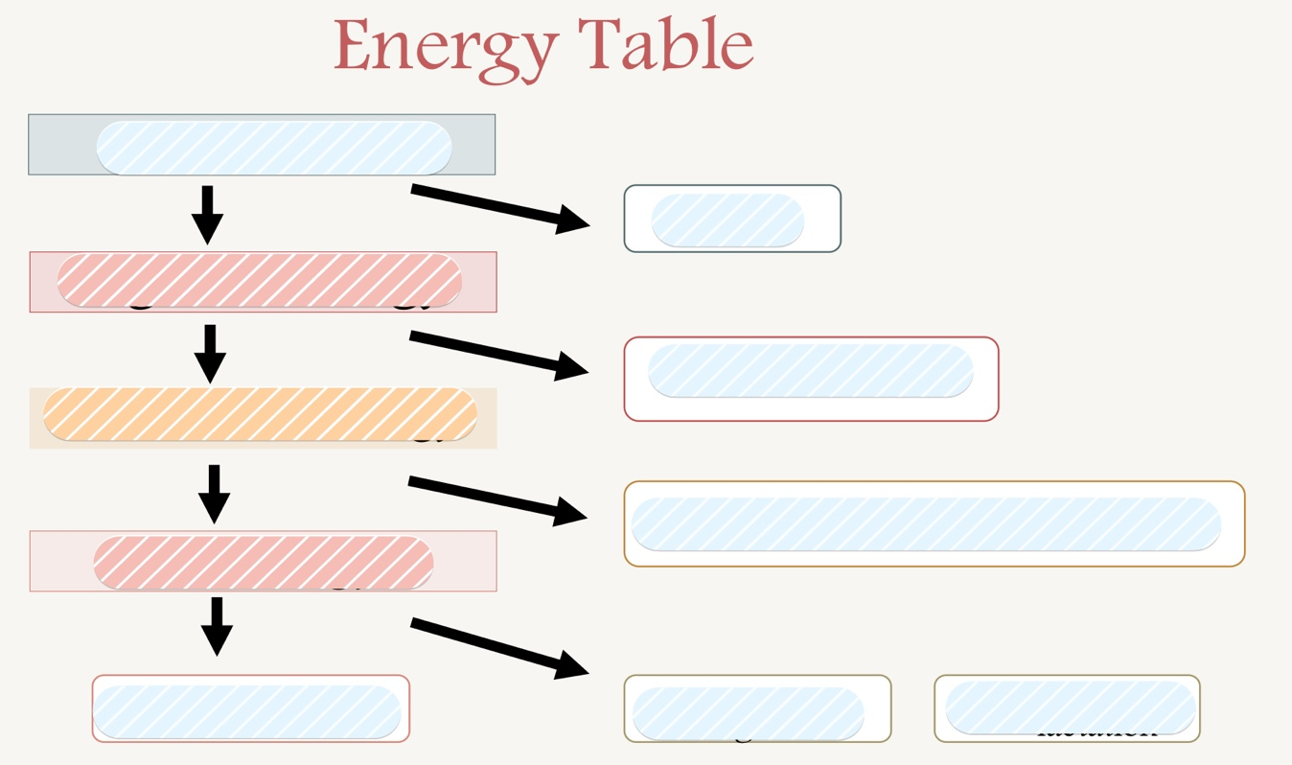

Label animal response with the intake of an essential nutrient:
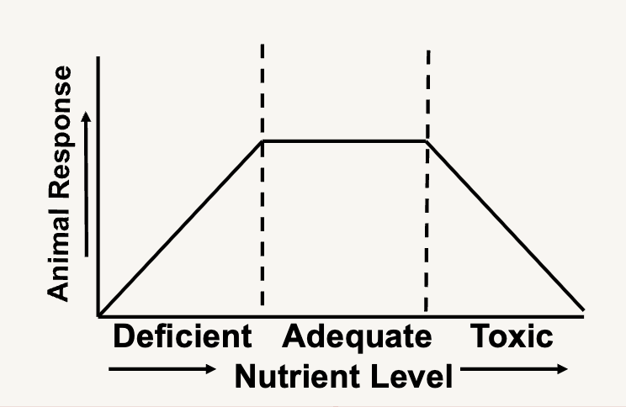

What are the clinical signs of dehydration? (cattle, sheep, horses, swine)
Cattle and sheep

Horses

Swine

Protein

What are proteins?

What is the difference between an essential and non- essential amino acid?
Essential protein:

Non-essential:

Why is protein supplemented in the diet?

What is typically the most expensive nutrient?

How many essential amino acids are needed in the diet of a growing animal?

Which amino acid is a semi-essential amino acid?

How many essential amino acids are required In adult animals:

There are ___________ naturally occurring amino acids

Microbes utilize ___________________ needed for amino acid synthesis in ruminants

What is the first limiting amino acid?

What are some limitations of crude protein?

List the essential amino acids ( Hint: PVT TIM HALL) :

List the 4 protein structures and define them:

What are the limitations of crude protein?

Carbs

What are 3 types of carbohydrates?

Carbs are formed through ______________ in plants

Carbohydrates have a gross energy of __________ kcal/g

What type of bonds constitute starches, sugars, and fiber?

Fats have __________ times more energy than carbohydrates

The main product of fermentation are__________________________.

_____________ is the most abundant carbohydrate and primary plant structural component
Cellulose increases as plants mature
Lipids

What are the 3 main functions of lipids?

Lipids have______________ kcal/g of gross energy

Label the following fatty acids as saturated or unsaturated:
