Exam 1 Test Prep
General Terminology and Major Nutrients
Define nutrition.

What is a nutrient? What is an essential nutrient?

Label the Animal Response in Relationship to intake of an essential nutrient!
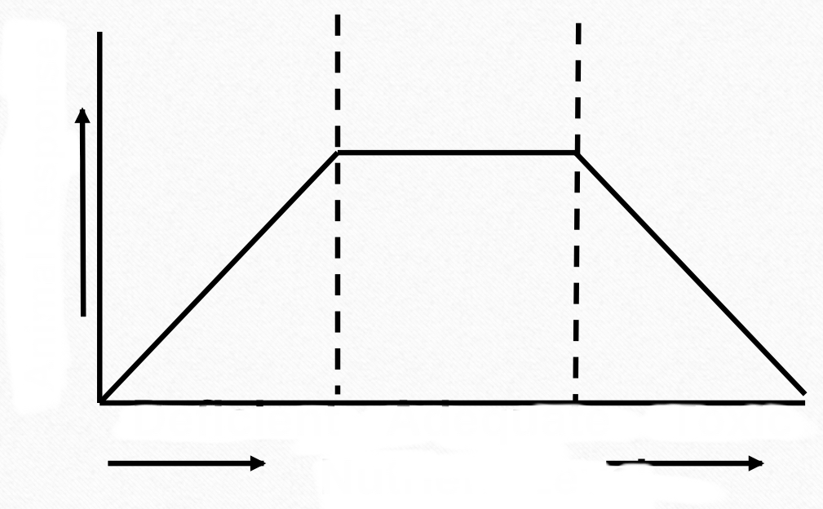

Define digestion and absorption. What are the 3 types of digestion?

Define metabolism.

What is the difference between anabolism and catabolism?

What is the energy balance at maintenance?

What is growth?

What is the difference between hyperplasia and hypertrophy?

Label and describe the growth curves.

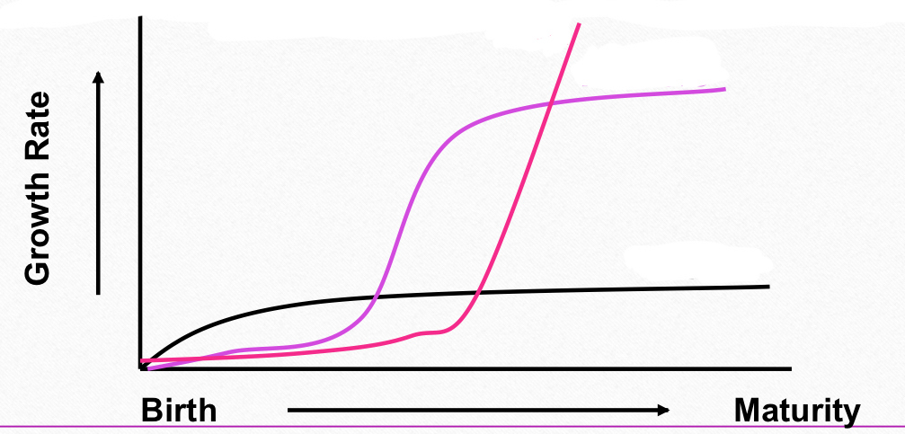

Label the energy table and define each step
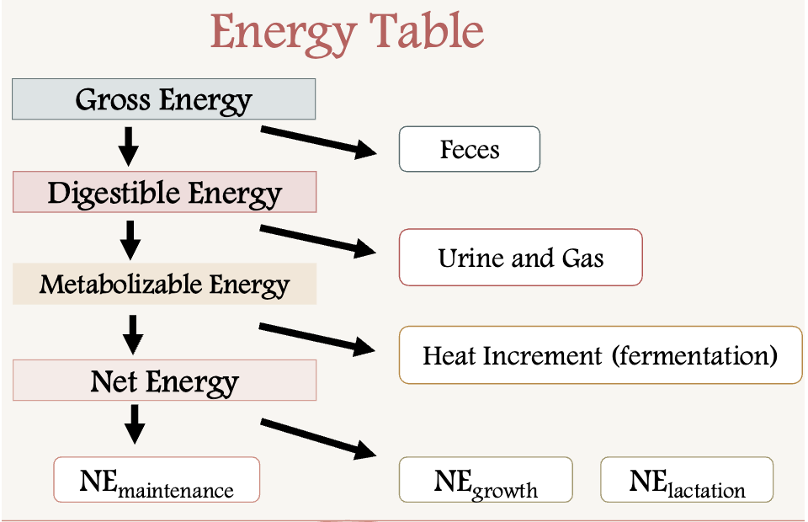

Water
Water makes up ________-_________% of body weight.

What are two types of water in the body?

List the functions of water (4):

List the sources of water:

What is the relationship of water in the body to age?

Signs of Dehydration

Protein
Protein is typically the _____________________expensive nutrient

Proteins have ____________________kcal/g of energy

What does the crude protein indicate? Write the formula.

What are the limitations of crude protein?

What are proteins, and what roles do they play in the body?

List the essential amino acids ( Hint: PVT TIM HALL) :

Which one is semi-essential? Why?

Between ruminants and non-ruminants, which one needs specific amino acid requirements :

Match the following amino acids to their correct definition:
Primary _____ 1- a helix further folded onto itself
Secondary_____ 2- two or more polypeptide chains united by non-covalent bonds
Tertiary_____ 3 - the linear sequence of amino acids
Quaternary_____ 4- arranged in a helix formation

Ruminants utilize ___________ for amino acid synthesis by microbes in the rumen

Name the following chains of amino acids:
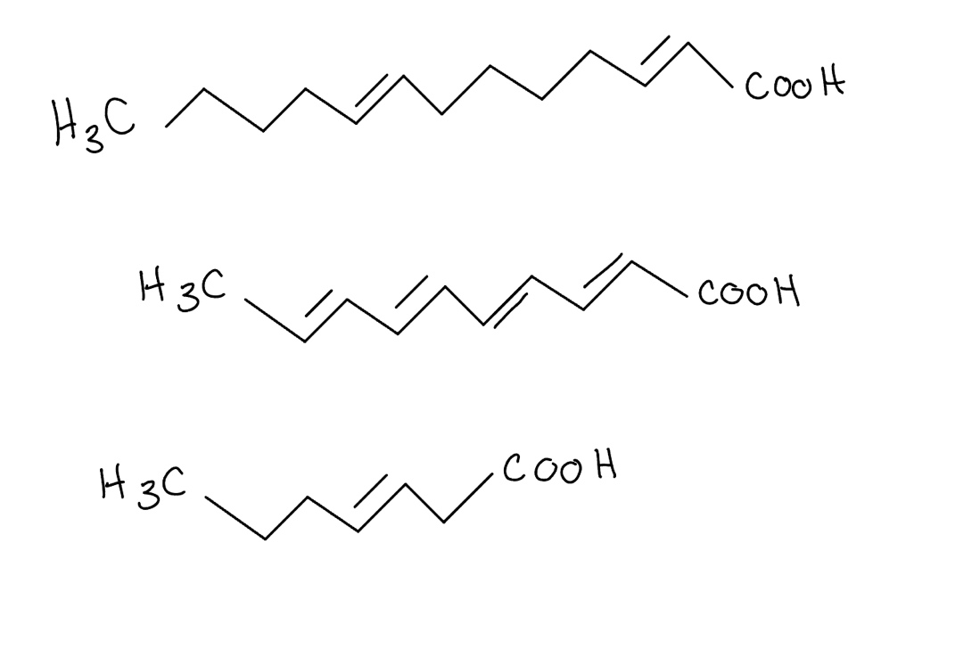
Carbohydrates
What are 3 main forms of carbohydrates? What type of polysaccharide bonds do they have?

The fundamental unit of carbohydrates is_____________________.

The most abundant carbohydrate and primary plant structural component is______________________.

Carbohydrates have _____________ kcal/g of gross energy.

Define the end products of digestion in both non-ruminants and ruminants:

True or False: Glucose is absorbed through diffusion

What is the stored form of glucose?
Lipids
List the 3 main functions of lipid:

Lipids have________________ more energy than carbohydrates

Lipids have __________ kcal/g of gross energy
What enzyme is responsible for lipid uptake by cells?**

Explain the process of fat digestion in ruminants and non-ruminants:
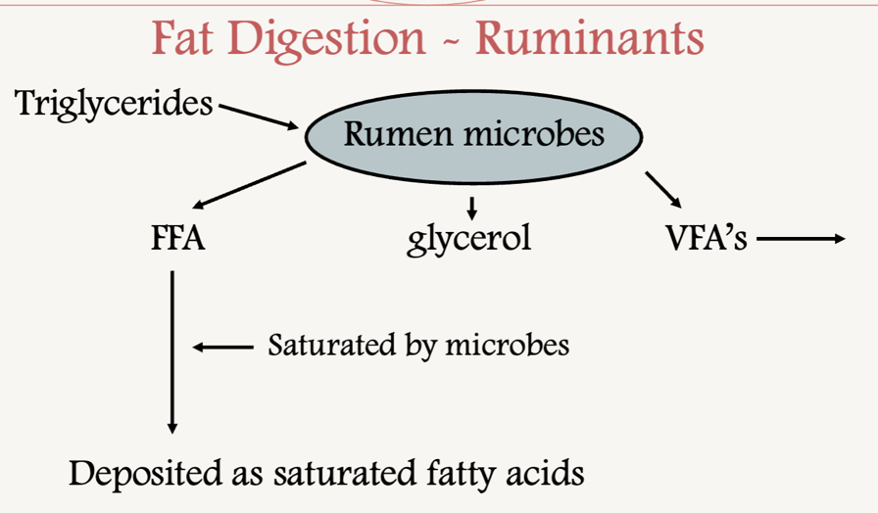
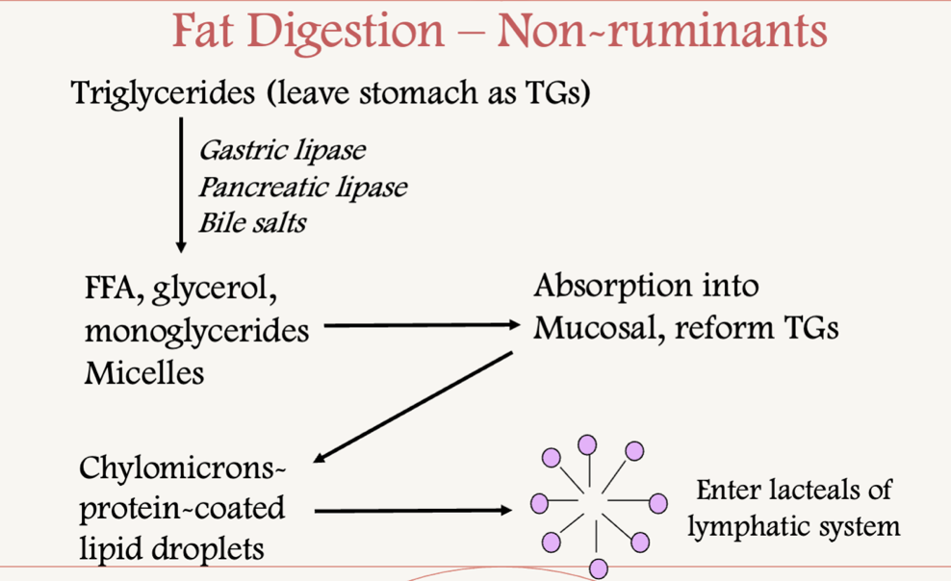

Label the following as saturated or unsaturated:
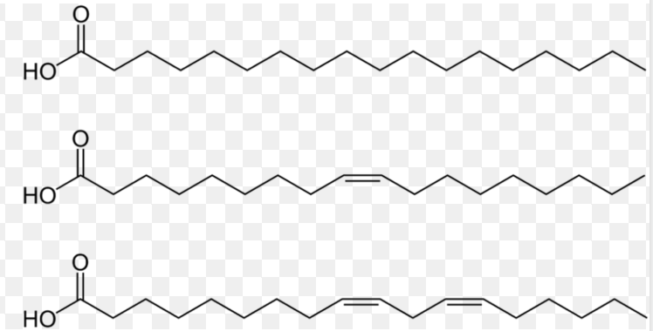

Vitamins and minerals
What are the 4 fat-soluble vitamins?

What are the two types of water-soluble vitamins?

Vitamins act as _____________ and ________________ for reactions

List the macro and micro (trace)minerals (hint: 7 macro, 8 micro) :
Macrominerals | Microminerals

Fed Analysis
Label the following flow diagram
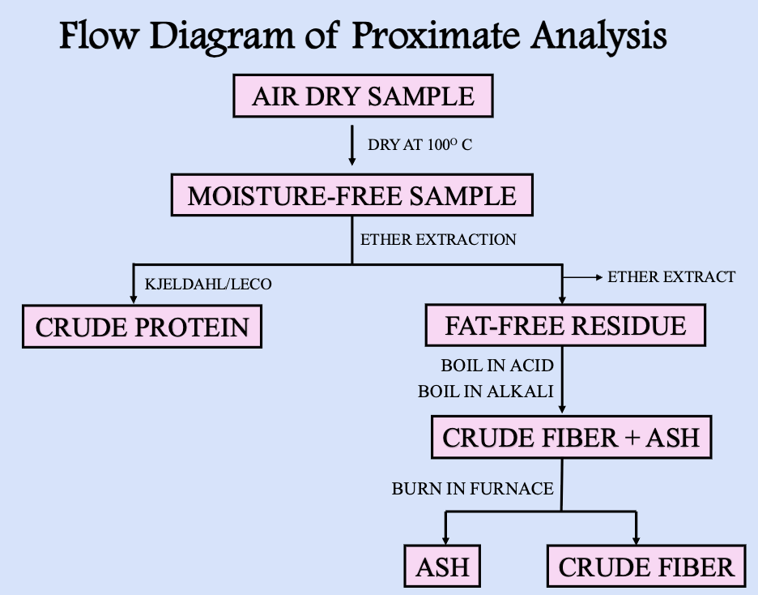
Formulas
Write the dry matter formula:

The percent moisture can be determined by:

Crude protein Formula:

Dry matter Intake:

Dry matter calculations
Problem:
Wet sample: 34.8
Dry Sample: 26.9
What is the dry matter percentage?

Dry matter intake
A lamb consumes 12 lbs of an alfalfa hay mix at 71% DM?
What is the DMI?

A livestock heifer consumes 25lbs of corn meal at 76% DM?
What is the DMI?

Cost analysis
Formula:
Silage A: 82% moisture at $45/ton
Silage B: 74% moisture at $62/ton
Which is the better silage for dollar value?

What are the two main methods of protein analysis?

What is the purpose of the two main methods of protein analysis?

Name the chemical used for fat removal for proximate analysis:

Nitrogen content of a feed is 6.70%, what is the crude protein of soybean meal?

Which system largely overcomes the limitations of CF?

What is the difference between NDF (Neutral Detergent Fiber) and ADF (Acid Detergent Fiber)?

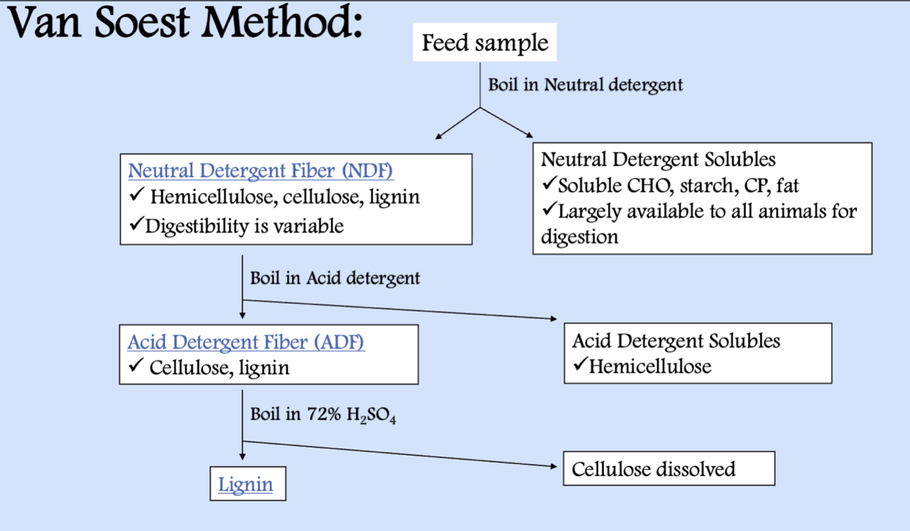
What is the purpose of bomb calorimetry?

