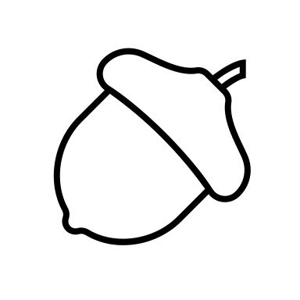 Vitamins and minerals + Feed Analysis

What are the 4 fat-soluble vitamins?
A, D, E, K
*A dinosaur eats kids*
What are the two water-soluble vitamins?
Vitamin B and C
List the main macrominerals:
Ca, P, mg, K, Na , Cl, s
List the main microminerals:
Fe, Zn, Cu, Se, I, Mn, Cr
What is the function of vitamins and minerals?
They act as coenzymes and cofactors for reactions
- Assist in proper Metabolic reactions
How can animals acquire minerals and vitamins?
- Occur naturally in plants
- May be included in a premix
Match the fat-soluble vitamin to its function:
A – Retinol (eyes)
D – cholecalciferol (bone health)
E – Alpha tocopherol (protects cell membrane against free radicals/fortifies cell membrane)
K- menadione (blood clotting factors)

List the water-soluble vitamins:
B1,2,3,5,6,7,9,12
c- Ascorbic acid (immunity health)

List the macro and micro (trace)minerals (hint: 7 macro, 8 micro) :
Macrominerals | Microminerals
• Calcium Ca  • Phosphorus P  • Sodium Na  • Chlorine Cl  • Potassium K  • Magnesium Mg  • Sulfur S  Cats Play Near Cloudy Kitchens Making Soup  - lb/ton | • Cobalt Co  • Iodine I  • Zinc Zn  • Iron Fe  • Copper Cu  • Manganese Mn  • Selenium Se  • ChromiumCr  Crazy Insects Zip Inside Caves, Making Spooky Chatter  - ppm or ppb

Fed Analysis
Why is feed analysis important?
- Want to determine what the animal is truly receiving
- Is the feed palatable to the animal, is it going to be eaten
- Determine digestibility
List the components of proximate analysis:
▪ 1) Dry Matter
▪ 2) Ether Extract (crude fat)
▪ 3) Crude Protein
▪ 4) Ash (minerals)
▪ 5) Crude Fiber
▪ 6) Nitrogen Free Extract (NFE)
Label the following flow diagram
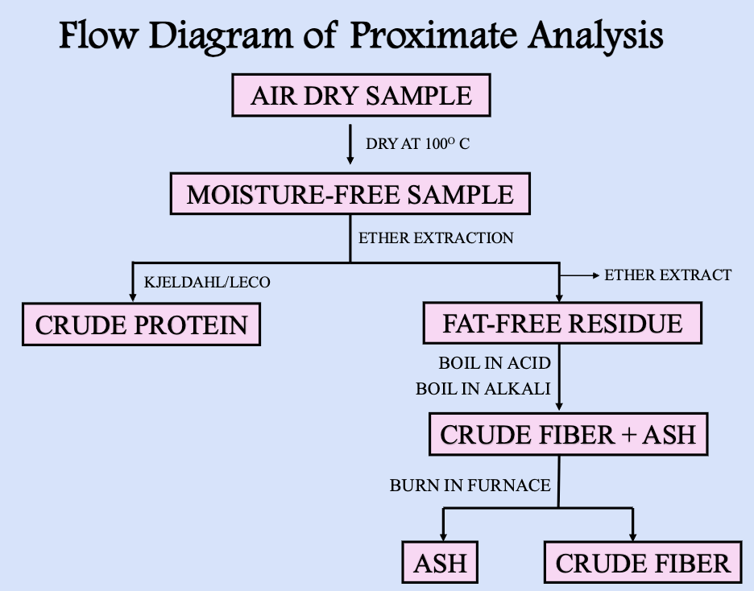
Formulas
Write the dry matter formula:
sample dry weight/ sample weight x 100 = Dry matter percentage
The percent moisture can be determined by:
100% - DM = % moisture
Crude protein Formula:
N% x 6.25= Crude protein

Dry matter calculations
Problem:
Wet sample: 36.8
Dry Sample: 27.4
What is the dry matter percentage?
$$\frac{27.4}{36.8}x 100=74.46\%$$
Problem:
Wet sample: 42.5
Dry Sample: 38.2
What is the dry matter percentage?
$$\frac{38.2}{42.5}x 100=89.88\%$$

Dry matter intake
A lamb consumes 13 lbs of an alfalfa hay mix at 76% DM?
What is the DMI?
$$13lbs x .76=9.88lbs$$
- Represents volume, carbs, and proteins

A livestock heifer consumes 22lbs of corn meal at 83% DM?
What is the DMI?

$$22lbs x .83=18.26bs$$

Cost analysis

Silage A: 84% moisture at $55/ton
Silage B: 52% moisture at $68/ton
Which is the better silage for dollar value?
100-84= 16 %DM
$$Silage A=\frac{55}{.16}=343.75 per ton of DM$$
100-52=48% DM
$$Silage B=\frac{68}{.48}=141.67 per ton of DM$$

Silage A: 74% moisture at $45/ton
Silage B: 66% moisture at $62/ton
Which is the better silage for dollar value?
100-74= 26 %DM
$$Silage A=\frac{45}{.26}=173.08 per ton of DM$$
100-66=34% DM
$$Silage B=\frac{62}{.34}=182.35 per ton of DM$$

Crude Protein

Ruminants need a source of _____________ for microbes to synthesize proteins
Nitrogen
What are the two main methods of protein analysis?
Leco and the Kjeldahl method
What is the purpose of the Kjeldahl method?
- Measures the N content of the sample, which is equal to the estimated total protein (crude protein)
List the limitations of proximate analysis:
- Assumes all N in feed is protein
- Not giving a true value of whether a protein is high quality or low quality
Calculate the crude protein percentage:
Jack is raising swine and preparing them for the upcoming livestock show. He is trying to determine the crude protein content of the soybean meal he will be using to finish his swine. Knowing the Nitrogen content of his feed is 8.40%, what is the crude protein of his soybean meal?
Soybean meal= 8.40% N X 6.25= 38% CP
- Assumes average N content of protein is 16%, 100/16= 6.25
What is NDF (Neutral Detergent Fiber)?

cellulose, hemicellulose, lignin
- indicator for intake*****
- close approximation of total fiber

What is ADF (Acid Detergent Fiber)?
Cellulose and lignin
- Predictor of the digestibility of a forage
- Approximates the less digestible fraction of fiber

