Part 1: Protein & Amino Acid Metabolism
Define the following terms:
Deamination: removal of the amine group from an amino acid for excretion
Transamination: the transfer of the amine group from one amino acid to make a non-essential amino acid
Urea Cycle: Process by which amino acids are broken down and excreted.

Define glycogenolysis:
- The break‐down of glycogen into glucose

What is glycolysis?
break‐down of one glucose molecule to two pyruvates

What is the Citric acid cycle?
- (Kreb’s or TCA cycle) An aerobic pathway in the mitochondria that uses Acetyl CoA to produce the equivalents of 25 ATP per mole of glucose

What is Gluconeogenesis?

- synthesis of glucose from non‐carbohydrate precursors

Nicotinamide adenine dinucleotide (NADH) Is used for ____________________________________ in the Krebs cycle.
- Electron transfer

The 4 G’s:
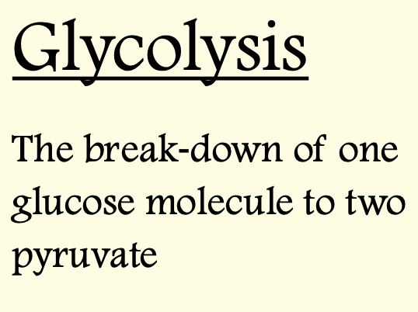
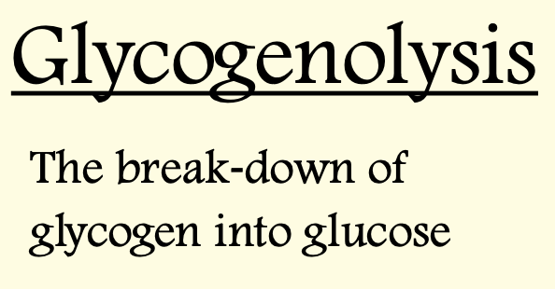
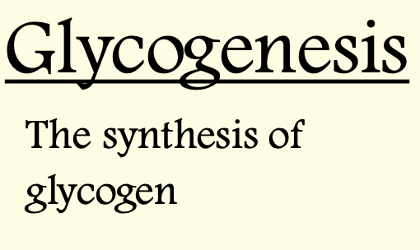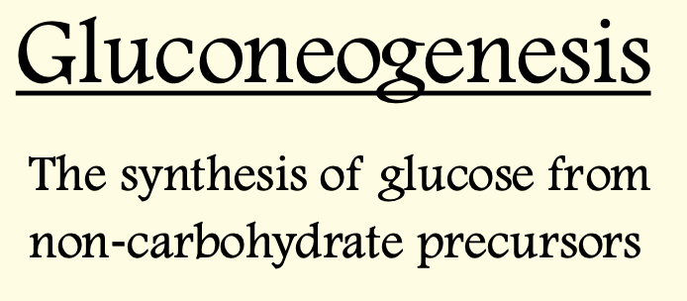

Define the following terms:
- UIP
Undegradable Intake Protein – portion of dietary protein that bypasses rumen degradation and is digested in the small intestine.
- DIP
Degradable Intake Protein – portion of dietary protein degraded in the rumen to ammonia for microbial protein synthesis.
- NPN
Answer: Non-Protein Nitrogen – nitrogen-containing compounds (e.g., urea) that can be used by rumen microbes to make amino acids and proteins.

True/False:
(a) Ruminants have true amino acid requirements just like monogastrics.
False – microbes synthesize amino acids, so ruminants have protein requirements but not “true” amino acid requirements.
b) Microbes in the rumen can convert NPN into microbial protein.
True
(c) The liver is the main site of the urea cycle.
True
Part 2: Metabolism of lipids
What molecule is considered the “molecular unit of currency”?
ATP, ATP is equal to 7.3 Kcal/mol

How much ATP per mole of glucose does the citric acid cycle produce?

  - 25 ATP

- What 4 pathways do dietary cholesterols go through after they are delivered to the kidneys?

- Bile acids formation
- Secretion into bile
- Incorporation in nascent
lipoproteins
- Storage in lipid droplets

- How is lipoprotein expression affected during fasting?
- Adipose cells will decrease in a fasting state
- Adipose cells will Increase in a fed state.

- Where is hepatic lipase (HL) secreted?
- The liver

- ________________________________ cAMP starts a cascade of reactions which stimulate other enzymes which break down fat (Beta Oxidation)
- cAMP

- What type of adipose tissue is obesity associated with?

- White adipose tissue
  - From the in ineffectiveness of leptin

- What is leptin? What gene is associated with leptin production?

- the satiety hormone produced by adipose cells appears to be a
potent regulator of food intake
- Ob gene is responsible for the production of leptin.

- Which fat type is important for heat generation? What animals will this type of fat mainly be seen in?
- Brown adipose tissue
  - Hibernating animals
  - Newborn animals

- Linolenic acid is a __________________________ fatty acid that is a precursor for _____________________________.

- Omega-3 fatty acid, long chain fatty acids
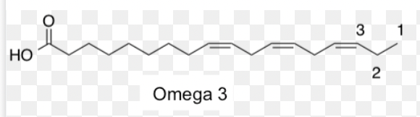

Things to keep in mind about the 2 fatty acids:
Omega-3 “good” fatty acid
Omega-6 fatty acids are overconsumed, can lead to inflammation

