Exam 1 Test Prep
General Terminology and Major Nutrients
Define nutrition.
- The sum of all processes an organism takes in and assimilates food, including digestion and absorption for, maintenance, promoting growth, and reproduction.
What is a nutrient? What is an essential nutrient?
Nutrient
- Any chemical element or compound in the diet that supports normal maintenance of life processes, reproduction, growth, or lactation.

Essential nutrient
- Nutrients that are required in the diet because they cannot be synthesized in the body in sufficient quantities to satisfy metabolic needs.

Label the Animal Response in Relationship to intake of an essential nutrient!
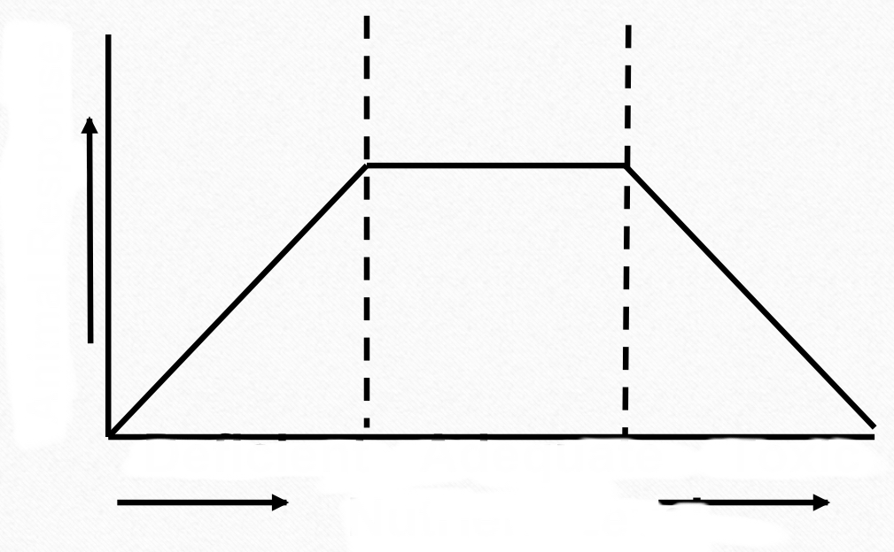
Nutrient level
Toxic
Adequate
Deficient
Animal response

*You want an adequate nutrient level for an adequate response

Define digestion and absorption. What are the 3 types of digestion?

Digestion
- Preparation of food or feed for absorption.
Absorption
- Passage of food or nutrients from the gastrointestinal (GI) traction into the bloodstream and its distribution
3 types of digestion
Mechanical
- Mechanical digestion involves physically breaking down the food into smaller pieces. Mechanical digestion begins in the mouth as food is chewed.

Chemical
- Chemical digestion involves breaking down the food into simpler nutrients that can be used by the cells.

Microbial
- Microbial digestion involves the breaking down of food by microbes, primarily used by ruminants

Define metabolism.
Sum of all biochemical processes that nutrients undergo to furnish energy and build new tissues

What is the difference between anabolism and catabolism?
Anabolism
•Build up of tissue
Catabolism
•Break down of tissue
*Anna builds sand castles
*Cats break blinds

What is the energy balance at maintenance?

The energy balance at maintenance is the Portion of food nutrients which support bodily processes which go on regardless of new tissue development or products formed. (HOMEOSTASIS)
**MUST BE MET FIRST BEFORE ANY OTHER REQUIREMENTS
What is growth?
An Increase in body weight or size.

What is the difference between hyperplasia and hypertrophy?
Hyperplasia
•Increase in cell number
Hypertrophy
•Increase in cell size

Label and describe the growth curves.

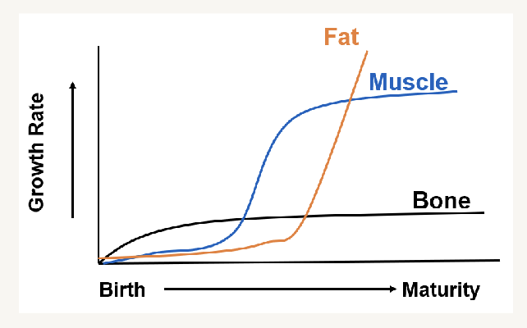
Fat:Fat accumulation, minimal during early growth stages as energy is primarily utilized for bone and muscle development
Muscle: Muscle growth happens rapidly during the adolescent portion of life as an animal starts to gain strength and size
Bone: Bone growth is more rapid during the early stages of life and slows down once the animal reaches maturity

Label the energy table and define each step
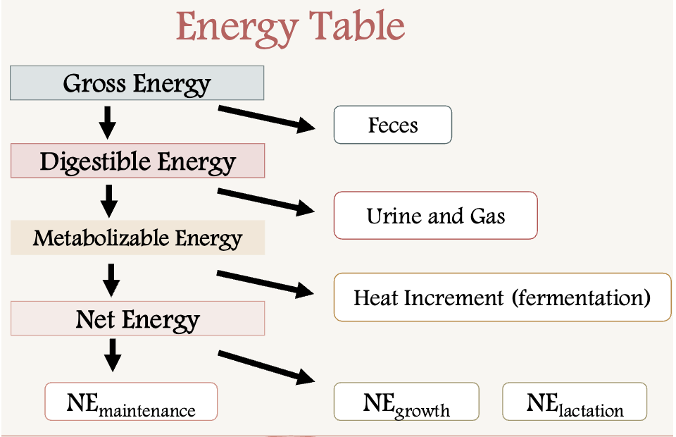
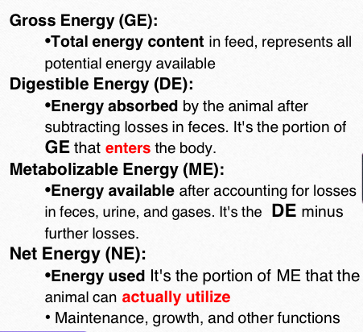

Water:
Water makes up ________-_________% of body weight.
45-85% of body water
What are two types of water in the body?
- Intracellular: Fluid within the cells
- Extracellular: fluids surrounding the cells
List the functions of water (4):
• Transport nutrients
• Solvent for chemical reactions
• Thermoregulation
• Lubrication
List the sources of water:
- Metabolic water
- Drinking water
- Water on feed
What is the relationship of water in the body to age?
Water is Highest in fetuses and newborns and is Lower in adults
** Water decreases as the animal ages, more fat in the body equals less water
Signs of Dehydration
Cattle and sheep
• Sunken, dull eyes
• In lactating cows, dehydration results in a near cessation of milk production.
Horses
• Reduced skin elasticity
Swine
• May result in salt poisoning and often is fatal
• Early signs include thirst, constipation, skin irritation and lack of appetite.
• Followed by nervousness, apparent deafness and blindness

Protein
Protein is typically the _____________________expensive nutrient
- Most
Proteins have ____________________kcal/g of energy
- 5.7kcal/g
What does the crude protein indicate? Write the formula.
- Estimate of the overall protein in a fed sample by measuring the nitrogen in a sample
- Formula: N% X 6.25= CP%
(Why is it 6.25? 16% is assumed to be nitrogen content of a protein, so 100/16= 6.25)

What are the limitations of crude protein?
- Assumes all N in feed is protein
- No info on AA composition or digestibility (remember protein quality)
What are proteins, and what roles do they play in the body?
- Long chains of amino acids (AA)
- Functions:
• Muscle
• Enzymes
• Structural components
List the essential amino acids ( Hint: PVT TIM HALL) :
Phenylalanine Threonine Hisodine
Valine Isoleucine Arginine
Tryptophan Methionine Lysine
Which one is semi-essential? Why?
Arginine, it is only required in growing/ younger animals not adults.
Between ruminants and non-ruminants, which one needs specific amino acid requirements :
Non-Ruminants
Non-ruminants: need specific amino acid requirements
Ruminants: need a source of nitrogen for protein synthesis from microbes

Match the following amino acids to their correct definition:
Primary _____ 3 1- a helix further folded onto itself
Secondary_____ 4 2- two or more polypeptide chains united by non-covalent bonds
Tertiary_____1 3 - the linear sequence of amino acids
Quaternary_____2 4- arranged in a helix formation

Ruminants utilize ___________ for amino acid synthesis by microbes in the rumen
- Non-protein nitrogen (inorganic forms of nitrogen like nitrates (NO‚ÇÉ‚Åª) and ammonia (NH‚ÇÉ), as well as organic compounds like urea)
- Must utilize carbs as a source of energy
- Urea is also a source of nitrogen

Name the following chains of amino acids:
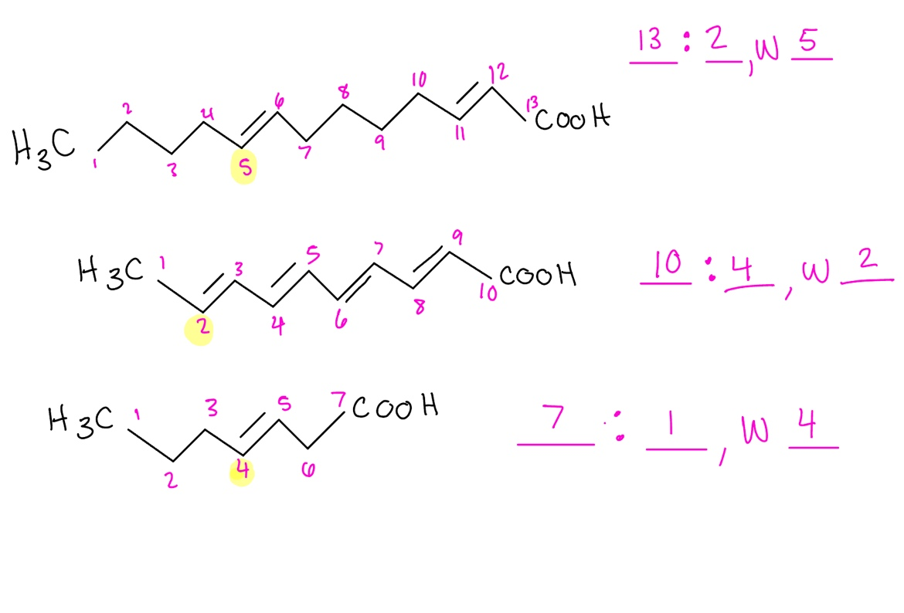
First: Start counting from the methyl group
Second: Count the number of double bonds
Third: The lowest carbon that the double bond falls on will be the omega

Carbohydrates
What are 3 main forms of carbohydrates? What type of polysaccharide bonds do they have?
Sugars, starches, and fiber
• Starches and sugars (alpha-bonds)
• Fiber (beta-bonds)
The fundamental unit of carbohydrates is_____________________.
- Glucose
The most abundant carbohydrate and primary plant structural component is______________________.
- Cellulose
Carbohydrates have _____________ kcal/g of gross energy.
- 4.1kcal/g
Define the end products of digestion in both non-ruminants and ruminants:
Nonruminants: glucose (monosaccharides)
Ruminants: VFA’s Volatile fatty acids- acetate, propionate, and butyrate
True or False: Glucose is absorbed through diffusion
FALSE, glucose is absorbed through active transport
What is the stored form of glucose?
- Glycogen
  - Glucagon regulates the breakdown of glycogen
  - Insulin regulates the uptake of glucose
Lipids
List the 3 main functions of lipid:
- Energy
- Insulation
- Protection
Lipids have________________ more energy than carbohydrates
- 2.25
Lipids have __________ kcal/g of gross energy
- 9.4 kcal/g

What enzyme is responsible for lipid uptake by cells?**
- Lipoprotein lipase
  - Breaks down chylomicrons and fat, which enter the cell
  - Chylomicron- large lipoprotein particles that transport dietary fats and cholesterol from the small intestine to the rest of the body via the lymphatic system and bloodstream
Explain the process of fat digestion in ruminants and non-ruminants:
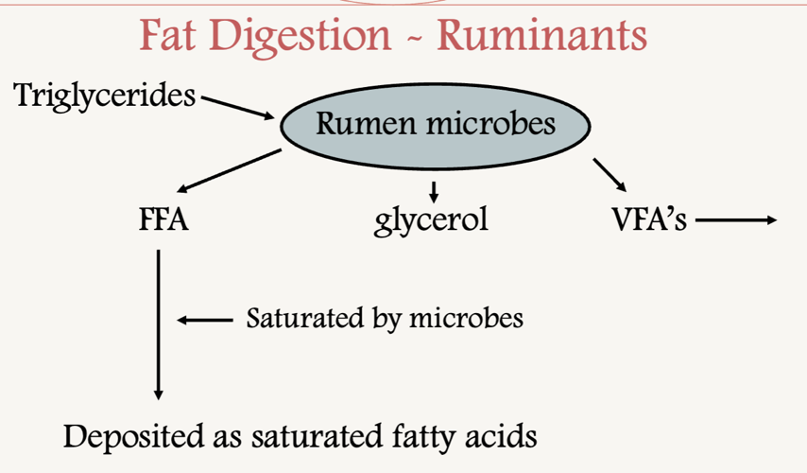
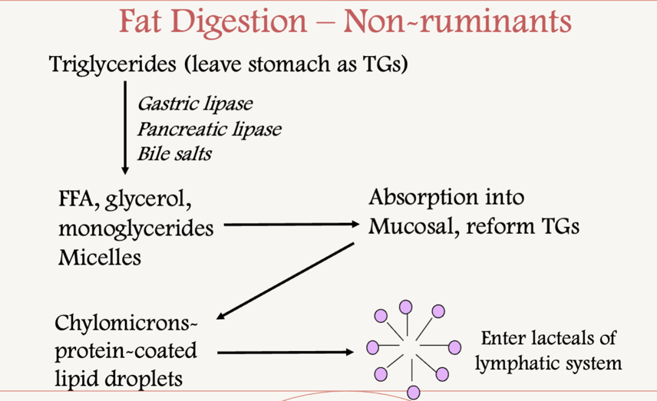

Label the following as saturated or unsaturated:
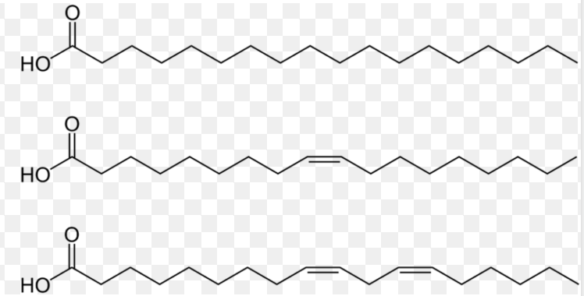
Saturated- non double bonds (hydrogens)
Unsaturated- double bonds
Vitamins and minerals
What are the 4 fat-soluble vitamins?
A, D, E, K
*A dinosaur eats kids*
What are the two types water-soluble vitamins?
Vitamin B and C
Vitamins act as _____________ and ________________ for reactions
- coenzymes and cofactors
List the macro and micro (trace)minerals (hint: 7 macro, 8 micro) :
Macrominerals | Microminerals
• Calcium Ca  • Phosphorus P  • Sodium Na  • Chlorine Cl  • Potassium K  • Magnesium Mg  • Sulfur S  Cats Play Near Cloudy Kitchens Making Soup  - lb/ton | • Cobalt Co  • Iodine I  • Zinc Zn  • Iron Fe  • Copper Cu  • Manganese Mn  • Selenium Se  • ChromiumCr  Crazy Insects Zip Inside Caves, Making Spooky Chatter  - ppm or ppb

Fed Analysis
Label the following flow diagram
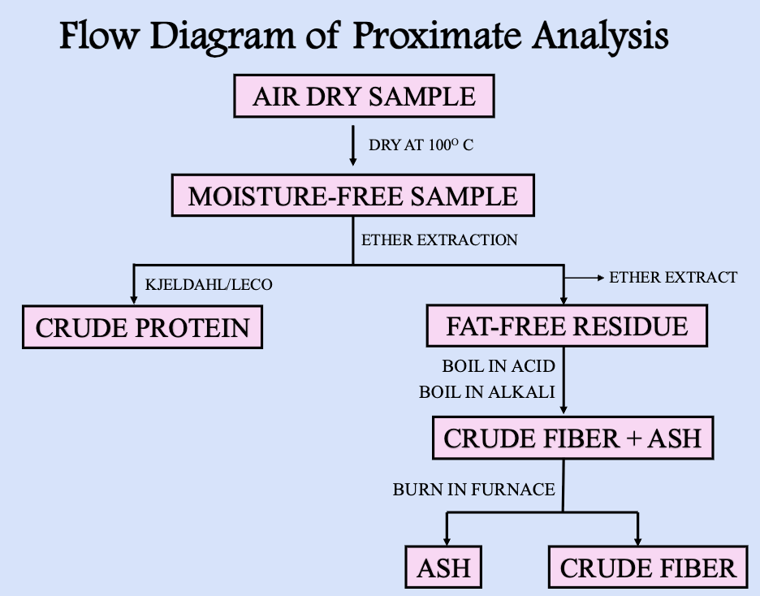
Formulas
Write the dry matter formula:
$\frac{Sample Dry Weight}{Sample Weight}$ X 100 = Dry matter percentage
The percent moisture can be determined by:
100% - DM = % moisture
Crude protein Formula:
N% x 6.25= Crude protein
Dry matter Intake:
#lbs consumed x %DM = #lbs DMI

Dry matter calculations
Problem:
Wet sample: 34.8
Dry Sample: 26.9
What is the dry matter percentage?
$\frac{Sample Dry Weight}{Sample Weight}$ X 100 = Dry matter percentage
$$\frac{26.9}{34.8}x 100=77.29\%$$

Dry matter intake
A lamb consumes 12 lbs of an alfalfa hay mix at 71% DM?
What is the DMI?
$$12lbs x .71=8.52lbs$$
- Represents volume, carbs, and proteins

A livestock heifer consumes 25lbs of corn meal at 76% DM?
What is the DMI?

$$25lbs x .76=19lbs$$
Cost analysis
Formula:
Silage A: 82% moisture at $45/ton
Silage B: 74% moisture at $62/ton
Which is the better silage for dollar value?
100-82= 18 %DM
$$Silage A=\frac{45}{.18}=250 per ton of DM$$

100-74=26% DM
$$Silage B=\frac{62}{.26}=238.46 per ton of DM$$

What are the two main methods of protein analysis?
Leco and the Kjeldahl method
What is the purpose of the two main methods of protein analysis?
- Measures the N content of the sample, which is equal to the estimated total protein (crude protein)
- Leco: Newer, faster, safer, and easier than Kjeldahl but expensive
- Kjeldahl: holder method, but has same assumptions that all N in feed is protein
Name the chemical used for fat removal for proximate analysis:
- Diethyl ether

Nitrogen content of a feed is 7.80%, what is the crude protein of soybean meal?
Soybean meal= 6.70% N X 6.25= 42% CP
.41875x 100= 42%
- Assumes average N content of protein is 16%, 100/16= 6.25

Which system largely overcomes the limitations of CF?
- The Detergent system or van sorest method
- Defines 2 fractions: ADF and NDF
What is the difference between NDF (Neutral Detergent Fiber) and ADF (Acid Detergent Fiber)?
NDF- cellulose, hemicellulose, lignin
- indicator for intake*****
- close approximation of total fiber
ADF- Cellulose and lignin
- Predictor of the digestibility of a forage
- Approximates the less digestible fraction of fiber
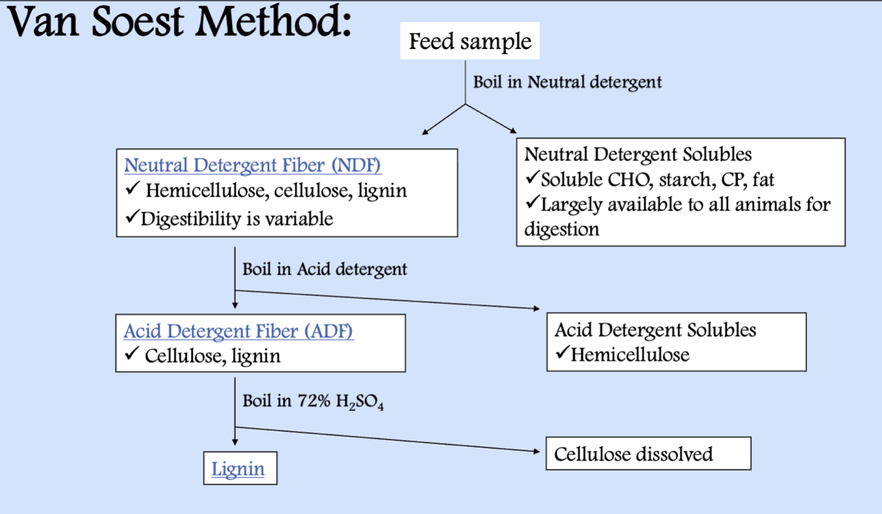

What is the purpose of bomb calorimetry?
- Measures energy content of fed

